St. Paul’s United Church

Welcome to Worship!

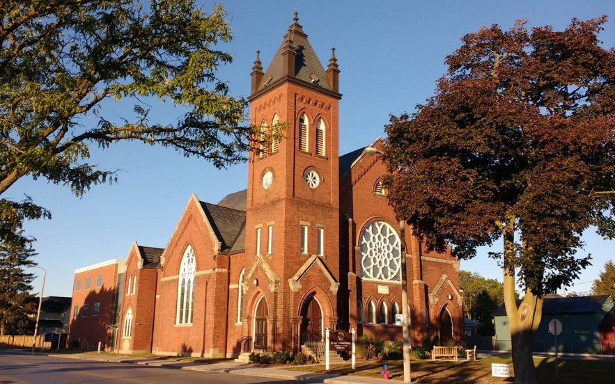

123 Main St E, Milton, ON L9T 1N4

St. Paul’s United Church
Welcome to Worship!

If you are a visitor, or looking for a friendly church home, we extend a warm welcome to you. Feel free to take this pamphlet home with you.

Minister: Reverend Christina Crawford
Music Director: Don Cassano

Please take a moment and fill out one of our welcome books, located on a table just outside the sanctuary, in the Atrium, or at the back of the sanctuary.

Please introduce yourself to our minister, either before the service, or as you leave. She will be pleased to follow up with a phone call or visit, if you are interested. However, please don’t feel any pressure. We will be in touch with you, as you feel comfortable, and/or are ready for further contact.

This may be your first experience at St. Paul’s United Church, and you may have questions about how we do things here. Every church is just a little bit different. We hope this booklet will help answer your questions and help you feel as comfortable as possible.

We are glad that you have joined us today and hope you enjoy the worship service!

St. Paul’s United Church is a diverse Christian faith community, nurturing itself through God’s word and a variety of worship experiences. In covenant with each other, we endeavour to be an example of Christ’s presence in our everyday lives and to do God’s work in the community.

When are worship services?

Services are at 10:30 a.m. on Sundays, in the sanctuary. During July and August, our service is held at 10:30 a.m. in the fellowship hall, as it is air conditioned.

Where or what is the sanctuary?

The sanctuary is the place where we gather for our Sunday morning worship service. If you enter in through the parking lot doors turn left, go through a set of double doors, and up a few stairs. The sanctuary entrance will be on the left after you go up the stairs. When coming in from the parking lot wheelchair ramp door, go straight through the door and into the sanctuary doors. If you enter through the glass doors off Main Street, there is a sanctuary door up the stairs on your right. The wooden door on the Main Street side of the sanctuary is open on Sunday mornings as well.

Where is the nearest washroom?

Leave the sanctuary by the south /west door, proceed straight down the hall and they are on your left.

How accessible is the church?

The entrance off the parking lot is wheelchair accessible, with a ramp that takes you to the main level. The sanctuary and fellowship hall are on the main level of the building. To access the upper or lower levels there is an elevator on the main level. The washrooms on the upper level are wheelchair accessible.

There are masks and hand sanitizers located at the entrances of the sanctuary for your convenience. However, masks are not currently required.

What should I wear?

People who attend St. Paul’s United Church wear a whole range of styles of clothing, from suits or dresses to jeans or shorts. Wear whatever you want to wear and know that you will be welcomed!

Where do I sit?

There is room for each one of us in our spacious and comfortable sanctuary. No one will formally seat you or assign you a seat. Just find a place where you feel comfortable. Our pews may be a bit hard on tender backs, so please feel free to take a cushion from the front south side of the sanctuary or bring any type of back support with you.

There are a few chairs at the back of the sanctuary for those who would find a chair a more comfortable seating arrangement.

At the very back of the sanctuary we have an area designated as a “kidz zone”. Children and families are welcome to access any of the toys or books in that area for use during worship. You are welcome to take the items with you to your pew or sit in the “kidz zone” area. Children usually head to their Sunday program immediately after “Time for the Young at Heart.”

Is it okay to move around once church has started?

Absolutely! We recognize that many folks may find sitting for an hour a challenge and so if you need to get up and stretch a bit, there is plenty of space at the back of the sanctuary to move about freely, without fear that you may be disrupting the service.

If you need to use the washroom, get a drink of water etc., please feel free to go ahead. If you need help, or are in distress, please let the minister know, or inform the person sitting closest to you. We will be happy to help in any way we can.

We recognize that parents with little ones may need to leave the service in order to warm bottles, change babies, or do whatever else unfolds while caring for God’s children. Please, do not worry. Come and go as you need to. There are washrooms on the main floor where the sanctuary is located, and a kitchen with a microwave, just off the fellowship hall.

We also recognize that at times little ones make noise. The “prayers” of little ones are a welcome sound in our sanctuary, so please don’t feel that you need to leave the service any, or every, time your child cries.

What about standing, sitting and kneeling?

At St. Paul’s United Church, the congregation stands for all hymns unless they are asked to be seated for a particular hymn.

If there is something special that requires standing, the Minister usually announces it. If you find standing a challenge, please don’t worry. Just remain seated.

At St. Paul’s United Church, we sit to listen (scripture readings, prayers, sermon, choir anthem and special music). We do not kneel at St. Paul’s United Church. Just keep an eye on someone near you and follow what they do.

During the “passing of the peace” at the beginning of the service, people get up and move around the church, greeting each other and shaking hands. If you are new and uncertain of this part of the service, just stand where you are, or remain seated. Someone from our church will come over and welcome you and introduce themselves.

How do I know what to do during worship?

There is a PowerPoint presentation of our order of worship displayed on screens at the front of each side of the sanctuary. When it is the congregation’s turn to read or speak, the text usually comes after the word “All” and is usually printed in bold. The lyrics to hymns will be projected on the screen but can also be found in one of our hymn books found in the pews. The hymns we sing are mostly from Voices United, and More Voices hymn books.

How do I know what is going on?

Our services, events, and activities are posted on our Facebook page. An email of church announcements is sent out weekly on Fridays. If you wish to be put on our emailing list, please contact the church secretary at info@stpaulsmilton.com. Announcements are displayed on the PowerPoint in the sanctuary before the service, and there is a television in the atrium which displays announcements as well.

Do people say prayers?

Prayer is an important part of any worship service. The prayers in bold print we pray together as a congregation.

We usually end our opening prayer with the Lord’s Prayer. The words will be displayed on the screen, or you can turn to page 921 in our Voices United Hymn Book. It is printed there. We use the version that has the extra two lines on the end (For thine is the kingdom, the power and the glory, forever and ever. Amen).

Is it okay to laugh in Church?

Of course! Laughter is energizing, as well as healing. The Minister feels better when we laugh at her jokes. It is okay to cry too. Sometimes we hear things that make us feel sad, or we are remembering a sad event. It is okay to laugh or cry.

Is it okay to clap in Church?

Clapping is welcome! It is a way to show our appreciation to our Choirs or a Soloist. Clapping also encourages us to get more involved in our worship service, and so anytime we are singing, and you feel the Spirit move you, please clap. We will join in!

Do I have to sing at Church?
Singing is an awesome way to connect with God, and singing is a big part of our worship! All voices are welcome. God doesn’t care whether you can carry a tune or not, and neither do we! However, if you are shy about singing, then just relax and let the music and voices of others speak to you.

If I have a baby, what do I do?

You are welcome to keep your baby with you in the sanctuary. There is also plenty of room at the back of our sanctuary if you need to move around. You are encouraged to remain in worship and just walk with your little one in that space as you need to.

Please do whatever makes you most comfortable. We are a “child friendly” congregation and love having little ones worshipping with us.

Do you have a children’s program?

Yes. We have Sunday School for children ages 3 to Grade 6, held in the fellowship hall. The children are usually in worship from the start of the service and leave for Sunday School after the “time for the young at heart”.

If you are new, please feel free to stay with your child during Sunday School. Please introduce yourself and your child(ren) to our Sunday School teachers, and they will assist them. They will be happy to answer any questions you may have about our Sunday School program.

We are pleased to assist you in ensuring that your children are safe, welcomed, and comfortable.

Where is the Fellowship Hall?

The fellowship hall is across the atrium from the sanctuary. To get to the fellowship hall from the sanctuary, go out either of the doors on each side the sanctuary across the atrium into the hall. We usually enter through the hall through the north door since the Montessori school occupies the south side of the hall through the school year.

Where are the meeting rooms?

There are two meeting rooms on the lower level. Take the elevator down to the lower level, cross to the other side of the hall, and the meeting rooms are on your right.

When entering off the parking lot proceed down the stairs, through the double doors and turn to your right. There is a meeting room straight ahead and on the left.

Where is the Minister’s Office?

The Minister’s office is located on the main level, beside the church office. See directions for entering the sanctuary and turn right. The office is on the right beside the fellowship hall.

Where is the Church Office?

The church office is located on the main level beside the Minister’s office. See directions for entering the sanctuary.

When are Office hours?

The office hours are Monday to Friday from 10 am to 2 pm. The office phone number is (905) 878-8895 extension 1. You are welcome to drop in. The doors are locked for the safety and security of our staff and renters. Use the intercom to the left of the door.

You seem to have a lot of doors here. Which ones do I use for what?

For Sunday worship, the glass doors off Main Street open at 9:45 am and remain open during the service. The doors off the parking lot are open at 9:45 am and then are locked at 10:30 am when the service begins. In the summer we keep the wooden sanctuary doors open.

Does the Church have a website?

Yes, it does. https://stpaulsmilton.com/

What is a sacrament?

A sacrament is a sacred or special act. We often refer to a sacrament as a visible sign of God’s invisible grace. It is an activity that we share in, as a congregation. It speaks to our faithfulness to God, and our commitment and caring for one another, as a community of faith. In the United Church we celebrate two sacraments: communion and baptism. Please speak to our minister if you have questions about either of these sacraments.

What is communion?

In some Christian churches, communion is referred to as the Eucharist or the Commemoration of the Lord’s Supper. In our church it is referred to as Communion, or Holy Communion.

Communion is a time of remembering. It is a sacred time. The bread we break, and the cup we share are symbolic of the bread and cup that were shared with Jesus and his disciples so long ago. This act of community, or communion, connects us to Christ and his followers throughout the ages.

As we share in this sacred meal, we remember with thanksgiving all the ways in which Christ continues to nourish us both personally and as a Christian community. We remember with awe that Jesus allowed himself to be broken so that we could be whole; that he poured out his whole self so that we could begin anew as a forgiven people. We remember that it is through Christ that we have been given the gift of eternal life.

Do you use wine for communion?

No, we use grape juice.

If I belong to another denomination, or I am not “baptised” or “confirmed,” can I still take communion?

In our church we remember that Jesus ate meals with people of all ages, stages, and walks of life. Jesus welcomed all people to any table he dined at, and so do we.

Our table is called “an open table” and it means that all are welcome. It doesn’t matter to us if you are a member – or not a member - of another church. All we ask is that you make space in your heart for Christ’s love.

Can my child take communion?

Just as Jesus welcomed and made time for children, we as a church, invite all children to join us in the sharing of communion. We believe children are an important and vital part of our church family, and so they are included in every aspect of our worship and church life.

If you as a parent have questions or concerns about your child(ren) sharing in communion, please speak to our minister. If you do not feel your child is “ready” to take communion, that is your decision and it will be respected.

I am allergic to wheat; will this be a problem for communion?

No problem. We do have a gluten free option in a separate bowl so that the elements are not contaminated.

Do we come up to the front to take communion?

St. Paul’s United does communion in the “Methodist” style, where people come to the front and pick up bread and grape juice from the servers and consume it there. If you cannot move easily to the front, the bread and juice will be delivered to you at your seat.

I would like to get my child or myself baptized. What should I do?

Please speak to Rev. Christina Crawford, our minister. She will be happy to meet with you to discuss this important event in your life, or your child’s life.

I would like to get married. What should I do?

Please speak to Rev. Christina Crawford, our minister at St. Paul’s United Church. The minister will be pleased to meet with any prospective wedding couples to introduce them to the church and encourage them to make it their church home. We encourage you to join us on Sunday for our worship service.

Do you marry same sex couples?

Yes! All people are welcome in our church. We are more interested in you being an active member of our church, than your sexual orientation.

If I would like a visit from the Minister, what should I do?

You can call her at (905) 878-8895 extension 3 or email her at stpaulsmiltonminister@gmail.com. The minister will look forward to meeting with you.

If I would like to participate in the service, what should I do?

If you would like to read Scripture, let the minister know and she can pass the information in to the worship committee. If you would like to join the choir, or offer the gift of music, please speak to our Music Director, after our worship service, or email him at donmcassano@hotmail.com. He will be in touch with you.

If you are interested in volunteering your time, and aren’t sure what direction to take, please speak to our minister and she will help you.

New ideas, and perspectives are always welcome!

I don’t have any money to put into the offering plate, is that okay?

Yes, God understands. You can just pass the offering plate to the next person, or if you are the only one in your row just hand the plate back to the person who gave it to you.

I have money to put into the offering plate, how much should I put in?

Your offering is a gift to God. It is a personal decision, between you and God. Offer God what you can when you can. Your life will be blessed through this giving!

Your offering is used in a variety of ways. Some of it goes to paying our ministry and church personnel, some to maintain our church programs and building, and some is utilized to provide support for those who are struggling in our community, nationally, and throughout the world.

I am coming on a regular basis. Should I get envelopes or something for offering?

We have several options:
- Traditional weekly in-church plate offerings of cash or cheques made out to “St. Paul’s United Church.” You can ask for envelopes by calling the office (905) 878-8895. Please indicate how you would like the money divided – to local church expenses, to the national church “mission and service” fund. If you have other special donations, it can be written under “other.”

- E- transfer to info@stpaulsmilton.ca. Please include your address in the comments section of the email so we know where to mail your receipt at tax time.

- PAR: automatic monthly remittance (giving) program. Arrangements can be made to have a certain amount withdrawn from your bank account every month. If circumstances change, you can change the amount. PAR helps the church manage its budget as your offering comes in every month. To go on PAR, there is information on the stable outside the church office. Take one of those, fill it out and place it into the collection plate or return it to the church secretary.

- The Canada Helps feature on the church website: https://stpaulsmilton.com/

Thank you for your generosity!

I still have questions, who should I talk to?

We hope this booklet has answered your questions, but you may have more that we have not thought of. Our church is a very welcoming place, and you will always find people who would be happy to help in any way.

Look for one of the greeters - they are the folks who greet you as you enter the church. They will do all they can, to make you feel as comfortable as possible here at St. Paul’s United Church.

We usually gather for coffee in the fellowship hall right after our worship service. Please join us and again, you will find that we are glad to meet you, and answer any questions you may have.

You are a blessing to this worship time!

Please join us next Sunday as well!

